|  |  |  |  |  |
| --- | --- | --- | --- | --- |
|  |  |  |  |  |
| Spring Harvest Quesadilla with Cheese, potato, spring onion and tomato salsa (V) | Chilli BBQ Beef & Bean Ragu with Penne | Roast Chicken with Gravy & Roasties | Chicken, Tomato & Coconut Dhal with Steamed Mixed Rice | Sustainably-sourced Battered Fish & Chips |
| Crispy Onion Mac & Cheese (V) | Falafel power bowl with Hummus, Grains, Rice & Salad (Ve) | Roast Quorn with Gravy & Roasties | Roasted Coriander Sweet Potato & Chickpea with Tomato & Coconut Dhal with Steamed Mixed Rice (Ve) | Cheese & Tomato Pizza  & Wedges/Chips |
| Vegan Sausage Roll (Ve) | Chicken Tikka & Steamed Rice | Pepperoni Hot Subs | Sweet & Sour Chicken & Rice | Pepperoni Pizza |
|  |  |  |  |  |
| Broccoli, Baked Beans  Mixed Salad, Crisp Garlic Bread | Fajita Roasted Sweetcorn & Peppers, Persian Slaw, Baked Beans , Mixed Salad | Country Mixed Vegetables, Baked Beans , Mixed Salad | Baked Beans  Garden Salad, Sri Lankan Vegetable Salad, Wedges | Peas, Baked Beans  Mixed Salad |
| Marble Cake | Iced Sponge | Ginger Cake & Custard | Giant Chocolate Cookie | Apple Crumble & Custard |

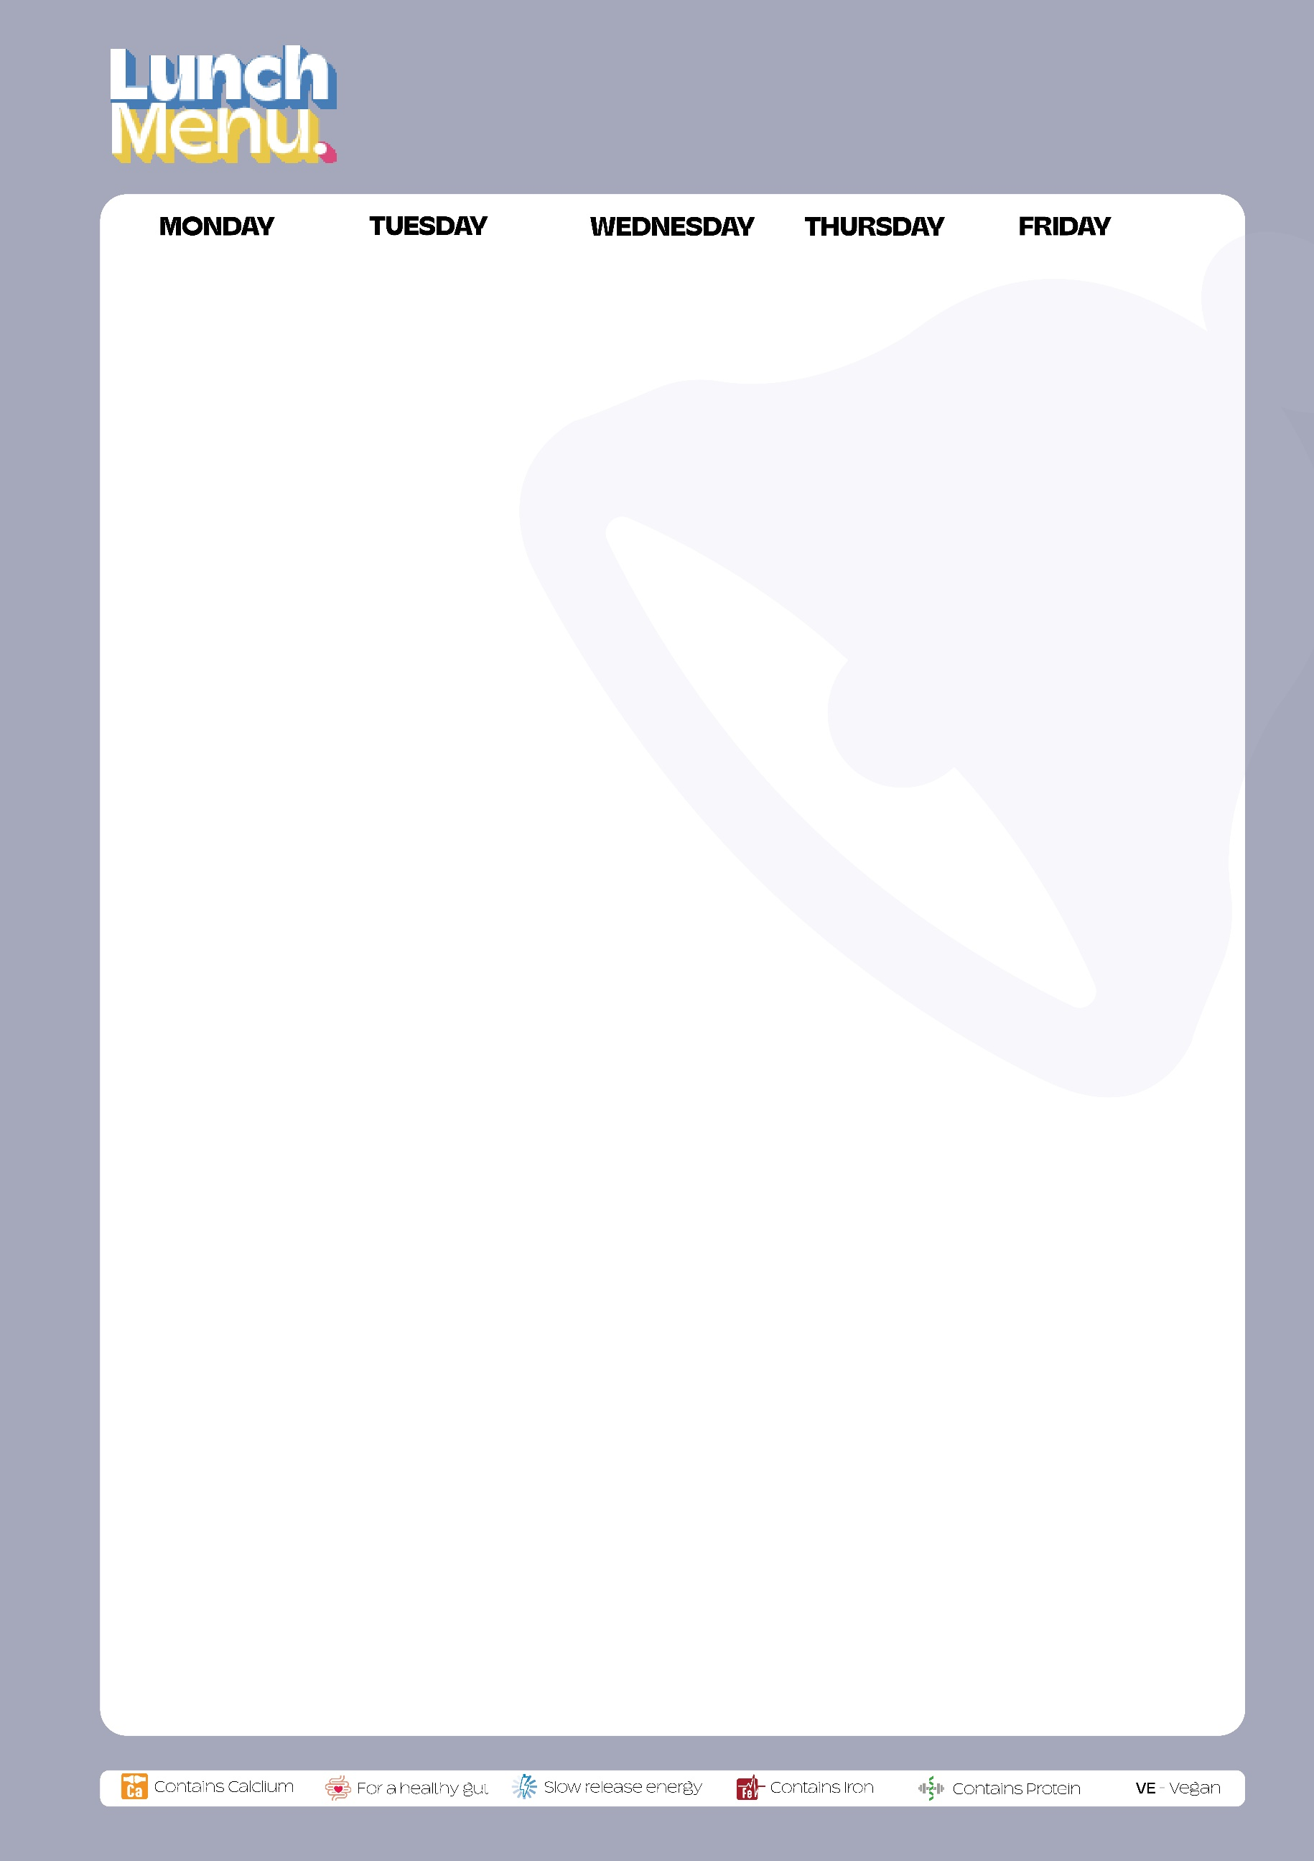

**WEEK 1**

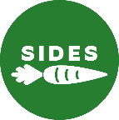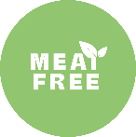

|  |  |  |  |  |
| --- | --- | --- | --- | --- |
|  |  |  |  |  |
| Cheese & Tomato 'Pizza' Macaroni Cheese (V) | Kashmiri spice bowl with beef, lentils & Mixed Rice | Roast Chicken  Crispy Roasties & Pan Gravy | Meatballs with Cheese and Arrabbiata Sauce & Penne Pasta | Sustainably Sourced Battered Fish & Chips |
| Buffalo Cauliflower & Mixed Bean Burrito | Cheesy Quorn Meatballs with Arrabbiata Sauce & Penne Pasta | Roasted Sweet Potato & Cheese Tart with Roast Potatoes | Vegemince Cottage Pie | Cheese & Tomato Pizza  & Wedges/Chips |
| Vegetable Chilli & Rice | Tomato & Basil Pasta | Pepperoni Hot Subs | Sticky Honey Hotdog & Onions | Pepperoni Pizza |
|  |  |  |  |  |
| Broccoli, Baked Beans , Mixed Salad, Crisp Garlic Bread | Fajita Roasted Sweetcorn & Peppers, Persian Slaw, Baked Beans ,Mixed Salad | Seasonal Mixed Vegetables, Baked Beans , Mixed Salad | Baked Beans , Asian Slaw, Garlic Green Beans, Garden Salad | Peas, Baked Beans , Mixed Salad |
| Lemon & Blueberry Slice with Custard | Flapjack | Iced Vanilla Sponge with Custard | Jam Sponge | Giant Chocolate Cookie |



**WEEK 2**





**WEEK 3**

|  |  |  |  |  |
| --- | --- | --- | --- | --- |
|  |  |  |  |  |
| Roasted Cauliflower Cheese Tart with Homebaked Potato Wedges | Beak Street Chicken with Savoury Rice & BBQ Glaze | Greek Style Layered Beef & Pasta Bake | Butter Chicken & Chickpea Curry with Rice | Sustainably Sourced Battered Fish & Chips |
| Vegetable Bolognese Pasta with Garlic Bread Slice | Brazilian Vegetable Stew with Savoury Rice (Ve) | Greek Style Vegetable Pastitsio (Layered Pasta Bake) | Roasted Cauliflower & Sweet Potato “Butter” Curry with Rice (V) | Cheese & Tomato Pizza  & Wedges/Chips |
| Vegetable Cheeseburger (V) | Cheese & Tomato Pizza | Halal Chicken Sausage Roll | Tomato & Basil Pasta Pot (Ve) | Pepperoni Pizza |
|  |  |  |  |  |
| Broccoli, Baked Beans  Mixed Salad, Crisp Garlic Bread | Baked Beans , Garden Salad, Roasted Sweetcorn, Wedges | Italian Garden Salad, Country Mixed Vegetables | Baked Beans   Steamed Broccoli | Peas, Baked Beans  Mixed Salad |
| Jam Sponge | Marble Chocolate Sponge with Custard | Lemon Drizzle Cake | Iced Orange & Ginger Traybake with Custard | Giant Vanilla Cookie |

